BO-COAX RG06 AU-ZH 75 OHM  DOUBLE SCREENED 75 OHM RF COAXIAL CABLE | 
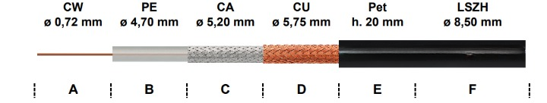

Image for illustration only

(A) INNER CONDUCTOR | COPPERWELD | ø 0,72
(B) DIELECTRIC | LOW DENSITY POLYETHYLENE | ø 4,70 ± 0,10 mm
(C) 1° BRAID | SILVERED COPPER  - COVERAGE | 168 x 0,13 mm  97%
(D) 2° BRAID | PLAIN COPPER  - COVERAGE | 168 x 0,13 mm  95%
(E) NON-MIGRATING | POLYESTER TAPE | h. 20 mm
(F) SHEATH  - COLOUR  - PRINTING | FLAME RETARDANT NON-CORROSIVE THERMOPLASTIC FREE OF HALOGENS  - BLACK - RAL 9004  - Standard | ø 8,50 ± 0,10 mm
Technical Data | Minimum Bending Radius (mm):  - Singel  - Repeated  Temparature Range:  Cable Weight (Kg/Km):  - Copper  - Plastic  - Total | ø EXTERNAL X 5  ø EXTERNAL X 10  -40 °C / +80 °C  50,5  63,9  114,4
Electrical Data  (ELECTRICAL PROPERTIES at 20°C) | Impedance:  Capacitance:  Velocity Ratio:  Resistance:  - Inner Conductor  - Braid  Tension:  - Sheath Spark Testing | 75 ± 3 Ohm  67 pF/m  66%  97 Ohm/Km  5 Ohm/Km  7,0 kV

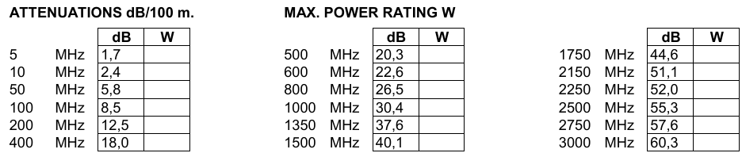
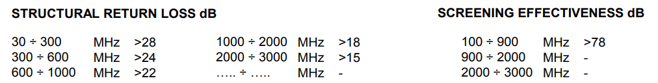

The producer reserves himself to make modification on the item without any notice

